Intro to api

Postman file name========evershop_final.

1. Inside search collection, pre-request:

function getRandomArbitrary(min, max) {

return Math.floor(Math.random() * (max - min) ) + min;

}

const dataSet=["Nike react", "Nike air", "Nike zoom"];

const randomNumber= getRandomArbitrary(0,2);

const searchedText= dataSet[randomNumber];

pm.collectionVariables.set("searched_text", searchedText);

in param====keyword===={{searched_text}}

====then run===

====in variable jeta randomly search kore setar nam dekhabe.

1. Then post response e ami eta likbo but

param e giye ajax=true likbo otherwise error

const responseBody=pm.response.json();

console.log(responseBody);

consol e gye dekbo success ashbe

1. Then eta dye dekbo j response tai dekhay

const responseBody**=**pm.response.json();

console.**log**(pm.response.status);

1. Then likbo

const responseBody**=**pm.response.json();

pm.**test**("Validate status code is 200", ()**=>**{

pm.expect(200).to.eql(pm.response.status)

})

pm.**test**("Validate success is true", ()**=>**{

pm.expect(**true**).to.eql(responseBody.success);

})

Eta lekhar por 200 status fail astese.

Then ami

const responseBody=pm.response.json();

console.log(pm.response);

**eta kore deklam j status er id te code:200 lekha so edit korbo.**

const responseBody=pm.response.json();

console.log(pm.response);

pm.test("Validate status code is 200", ()=>{

pm.expect(200).to.eql(pm.response.code)

})

pm.test("Validate success is true", ()=>{

pm.expect(true).to.eql(responseBody.success);

})

Success

Success========eta holo result

SECOND class==============

=======search option e ei code thakbe:

First e search run diye ami addtocart run disi. Tokon error dekhaise. Search er por previewcart run disi tokon error dekhaini. But eta to kora jabena. Error dekhabei. Ejnno d

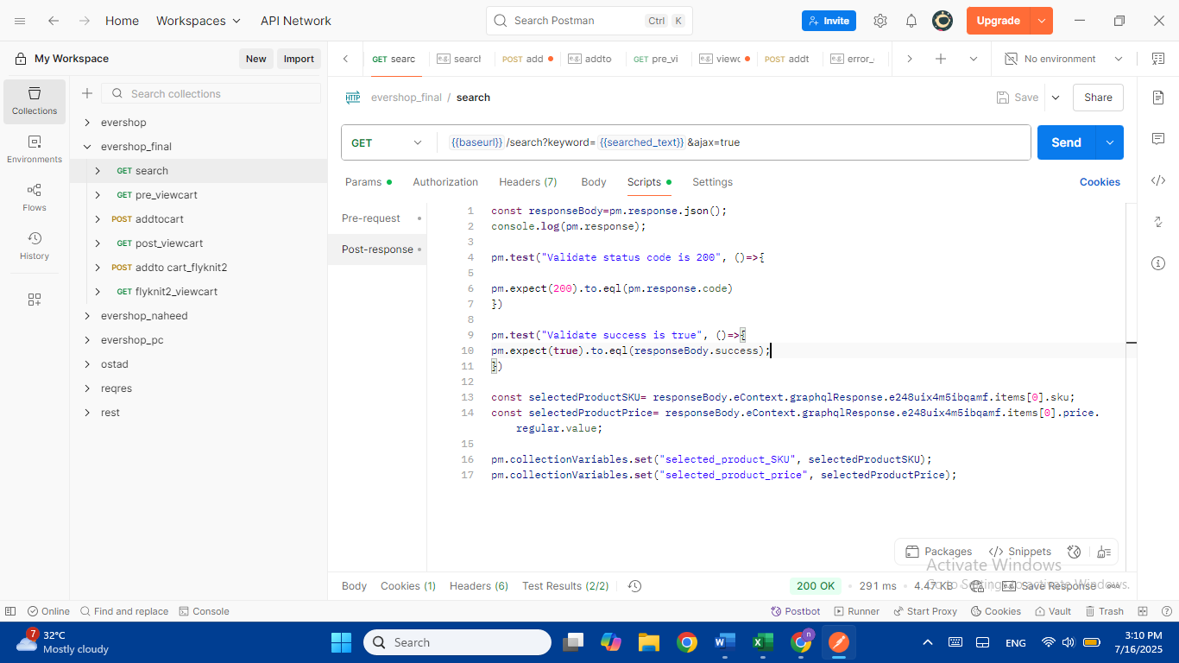

Then go to post viewcart

const responseBody**=**pm.response.json();

//console.log(pm.response);

pm.**test**("Validate status code is 200", ()**=>**{

pm.expect(200).to.eql(pm.response.code)

})

const actualPrice**=** responseBody.eContext.graphqlResponse.e248uix4m5ibqb80.subTotal.value;

const item**=** responseBody.eContext.graphqlResponse.e248uix4m5ibqb7y.items;

let qty, price;

let total**=**0;

**for**(i**=**0; i**<**item.length; i**++**){

qty**=** item[i].qty;

price**=**item[i].productPrice.value;

total**=**total**+** (qty**\***price);

}

//const totalQty=pm.collectionVariables.get("total_qty");

//const singleProductPrice= pm.collectionVariables.get("selected_product_price");

//const expectedPrice=singleProductPrice* totalQty;

//const expectedQty= pm.collectionvariables.get("totalQty");

pm.**test**("validate total qty is correct",()**=>**{

pm.expect(total).to.eql(actualPrice);

})

Then run the post_viewcart

Variale e giye baseurl likhe otar under e likhbo <https://demo.evershop.io>

Then eta baki link gulay update korbo.then view cart k upre nye pre_viewcart korbo

In newman report==========

To install=======

C:\Users\User>npm i -g newman

To run===========

newman run "D:\tuli\tuli vs code\api automation\evershop_final.postman_collection.json" -r htmlextra --reporter-htmlextra-export "D:\tuli\tuli vs code\newman\report.html"

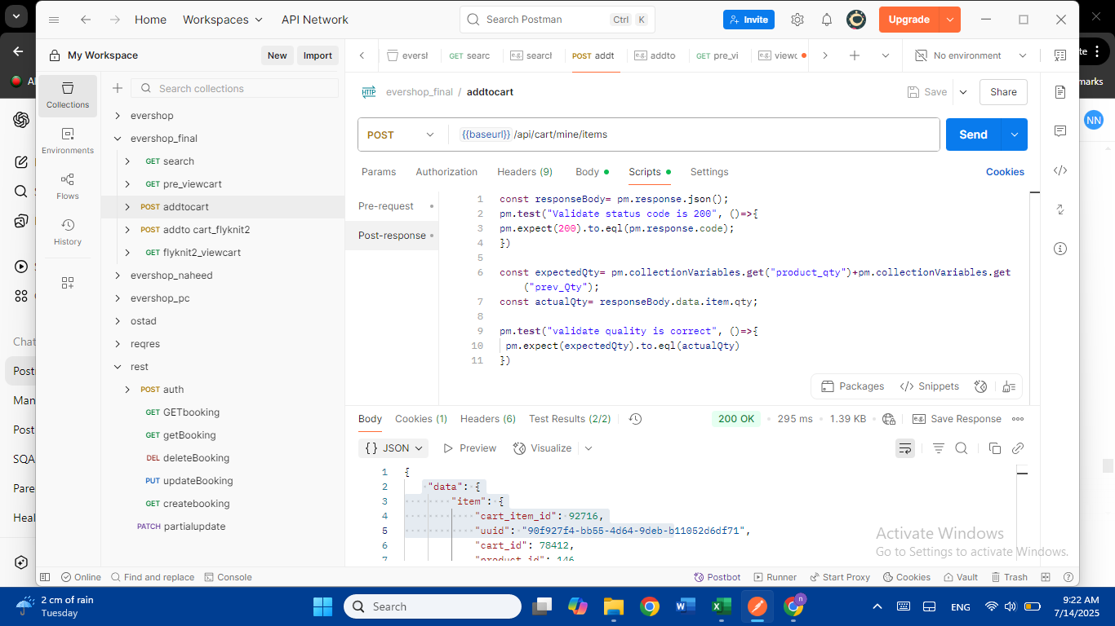

I had error in first line I didn’t write json()…dint give these bracket.

Final codes in postman for 4 diff collection:

Search collection

Then we see error in newman report.

We edit the code in previewcart

After running successfully all 4 json files in postman. I go to cmd,typ to download newman

newman run "D:\tuli\tuli vs code\api automation\evershop_final.postman_collection.json" -r htmlextra==============sir showed but not work mine

newman run evershop_final.postman_collection.json" -r htmlextra

=========to solve error we edit in previewcart

to run in newman=========================

for me======== report generate====



**FROM START=========**

1. **Microsoft store e giye ami terminal download korsi.**
2. **Then tuli vs code folder e right click korle open in terminal ashche.**
3. **Then mkdir api leksi. To CREAT API FOLDER**
4. **Then etar vitor api folder e ami json postman theke export korsi**
5. **Then cd api leksi jate api lekha uthe**
6. **Then ls dile amr postman file name dkehabe like below**

1. **Newman run dile error ashche tokhon ami powershel e right click kore run as administrator diye eta leksi (Set-ExecutionPolicy RemoteSigned), then (Y) disi, then newman run disi with (npm i -g newman).**
2. **Then age j api powershell use kortesilam otay giye newman run filename.json dye run disi success hoise.**
3. **Then for newman report just write (PS D:\tuli\tuli vs code\api> newman run evershop_final.postman_collection.json -r htmlextra)**